 

|  |
| --- |
| **FPT-aptech computer education** |
| **EProject Report** |
| [Auto Ancillaries Limited] |
|  |
| |  |  | | --- | --- | | **<Group 3>** | | | **Members** | Nguyễn Xuân Quý Đức  Dương Văn Hân  Lê Đăng Long  Nguyễn Văn Sĩ | | **Instructor** | Nguyễn Tuân | | **Batch** | C1207G | | **Semester** | 4 | |

Contents

Problem definition 3

Customer Requirement Specification 4

Inputs provided by the client 4

Hardware Requirements 5

Software Requirements 5

Scope of the work (in brief) 5

Architecture and Design of the Project: 6

Entity Relationship (ER) Diagram 6

# Problem definition

Auto Ancillaries Limited (AAL) is in the business of manufacturing important ancillaries for the two-wheeler and four-wheeler automobile industry. For the past few months they have been facing problems with their current system. Due to the problems they have felt the need for a change in their system. For this purpose, they have approached you to develop products. They would like you to study the problem at hand, and evolve a strategy for solving the current problems. In addition to this, they also want you to suggest solutions using which the company will get an added competitive edge in this cut-throat competitive market.

# Customer Requirement Specification

1. Registration of Member (Customer) to the Site
2. Creation, Maintenance and Updating of Database, which will contain

* Information regarding all transactions made
* Details of Customers
* Details of the Warehouses
* Details of items and stocks
* Details of the purchase orders
* Details of invoices
* Details of Material rejections

1. Login and verification
2. Entering query parameters by the user (Inventory status of company, rating of the customer, outstanding with the companies etc)
3. The company databases should maintain the following

* Details of customers
* Other information like inventory, order status etc. that it wants to forward to the service

1. Transmitting the queries to the servers of each Company.
2. Each server has to perform the search as per the query parameters.
3. The server has to transfer the data to the Web Site.
4. Presenting the result to the user in a consolidated format.
5. Accepting order booking from user.
6. Forwarding booking request to the particular Company server.
7. The order should be booked, server database updated in terms of availability.
8. The billing for the order is to be calculated taking into account the customer entitlements in terms of discount and credit period.
9. The member account should be updated in terms of finances and transactions.

## Inputs provided by the client

* Design Database.
* Requirements.
* Structural system.

## Hardware Requirements

* A minimum computer system that can access all the software tools listed below.
* 512 MB of RAM or higher.
* Have at least one web browser installed on computer.

## Software Requirements

* NetBeans 7.2+.
* MS SQL Server 2010+.

## Scope of the work (in brief)

# Architecture and Design of the Project:

# Entity Relationship (ER) Diagram

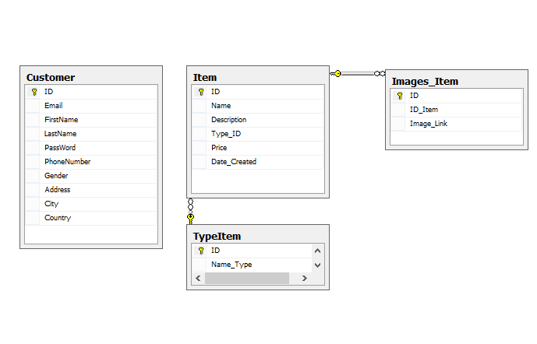

# Task Sheet

|  |  |  |  |  |  |  |  |
| --- | --- | --- | --- | --- | --- | --- | --- |
| **Project Ref. No. :** | | **Project Title:** | **Activity Plan Prepared By:** | **Date of Preparation of Activity Plan:** | | | |
| **No** | **Task** | **Actual Start Date** | **Actual Days** | **Team Member Names** | **Status** |
| 1 | Database Design | Auto Ancillaries Limited | Nguyễn Xuân Quý Đức  Dương Văn Hân  Lê Đăng Long  Nguyễn Văn Sĩ | 10-06-2014 | 3 | Nguyễn Xuân Quý Đức  Dương Văn Hân  Lê Đăng Long | Completed |
| 2 | View Item. | 14-06-2014 | 1 | Nguyễn Xuân Quý Đức | Completed |
| 3 | Insert, Update, Delete Item Site | 16-06-2014 | 4 | Nguyễn Xuân Quý Đức  Dương Văn Hân | Completed |